**Name: Jeetendranath Jakkamsetti  
LWR Demo Project**

# **STOREFRONT SETUP**

## **R-01: Basic Data for Store Setup**

* Done the storefront setup with name Bicyclestop and added the required integration classes and the categories and the sub-categories as given in the requirement provided.  
  Reference for storefront setup: <https://rafterone.atlassian.net/wiki/spaces/TRAIN/pages/4390652395/Salesforce+B2B+Lightning+Storefront+Setup>

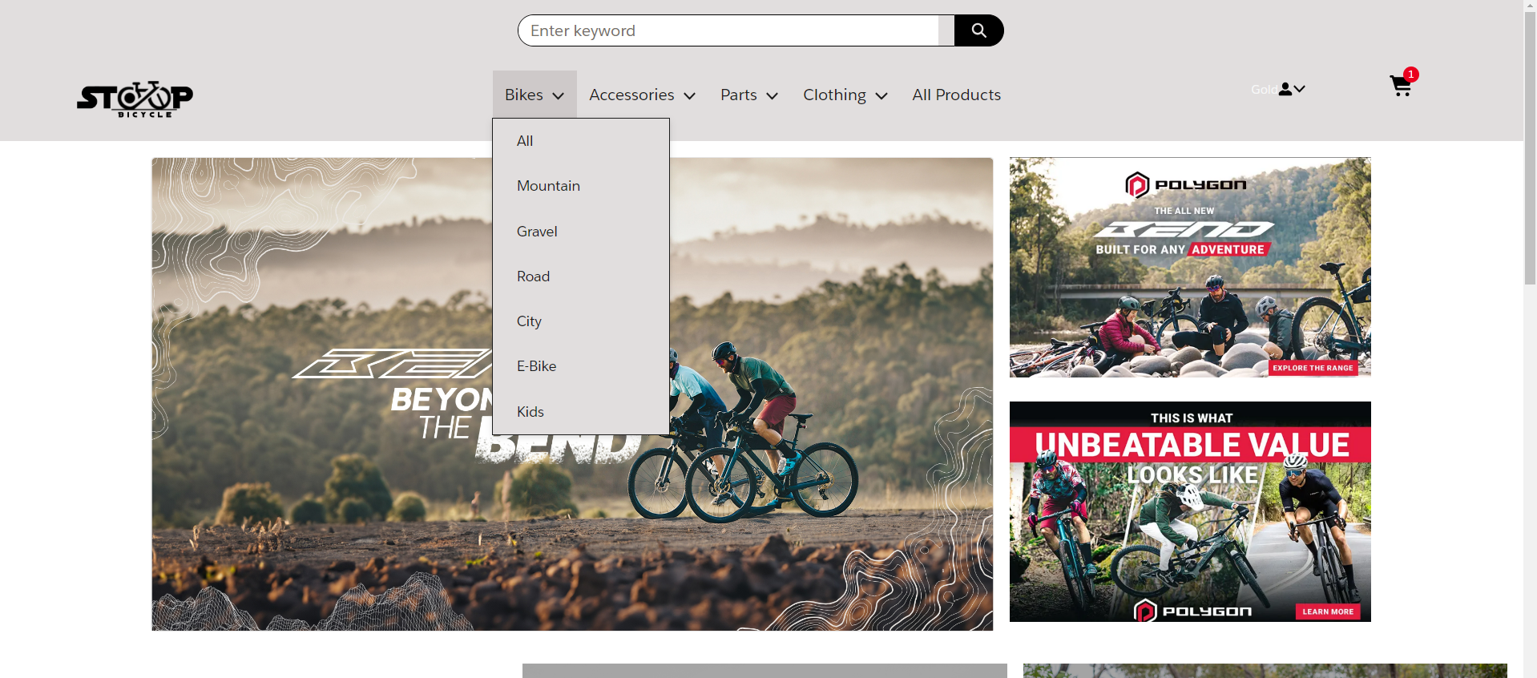

* Set up PriceBooks
* I had created the 3 pricebook based on the conditions.

|  |  |  |
| --- | --- | --- |
| **PriceBook** | **Users** | **Comments** |
| Bicyclestop Standard Pricebook | Guest Users |  |
| Registered Price book | Registered Users | 5% off of Std PB |
| Gold Price book | For Selected Accounts tagged as Gold Accounts | 10% discount on Bikes and 25% on all others off of Std PB |



* Buyer groups

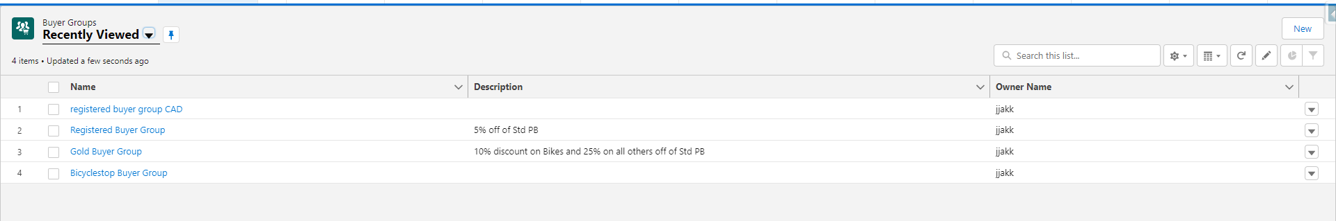

RegisteredBuyer Group For registered user.

Gold Buyer Group For Gold Users and assigned with the gold pricebook.

Bicyclestop buyer group for Guest users.

* Define Attributes on products to enable faceted search on the **Product List Page (PLP)**.

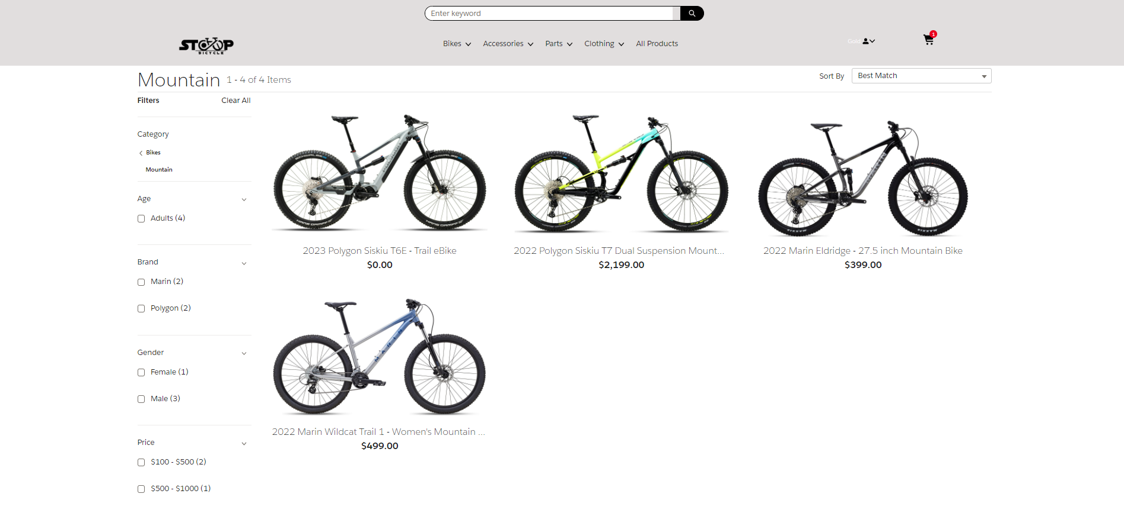

* **Set Up Promotions**
* Promotion for a specific product

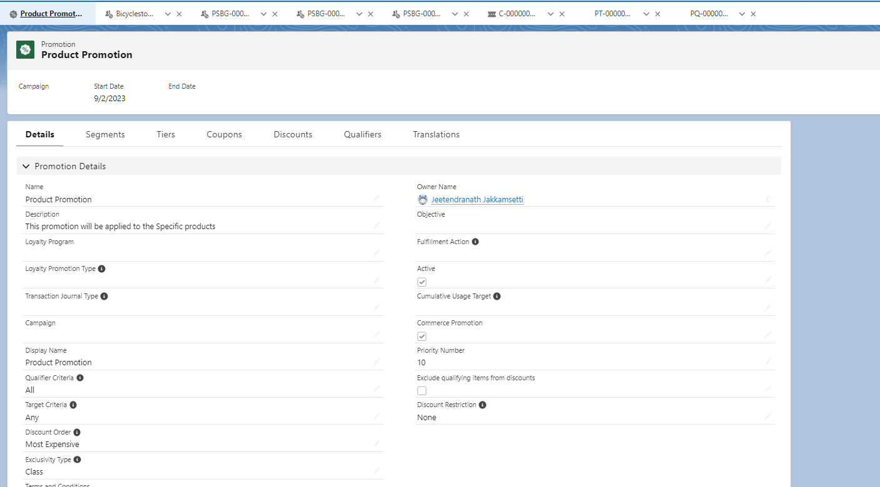

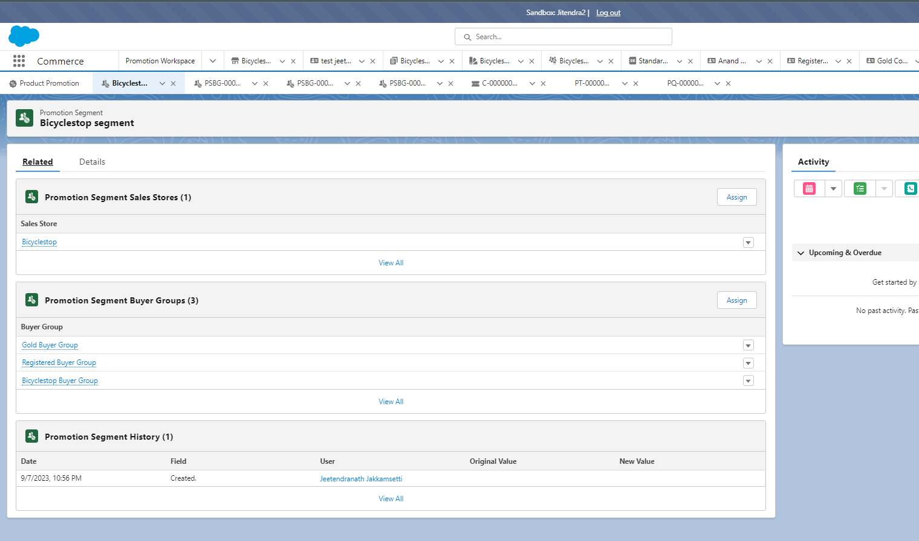

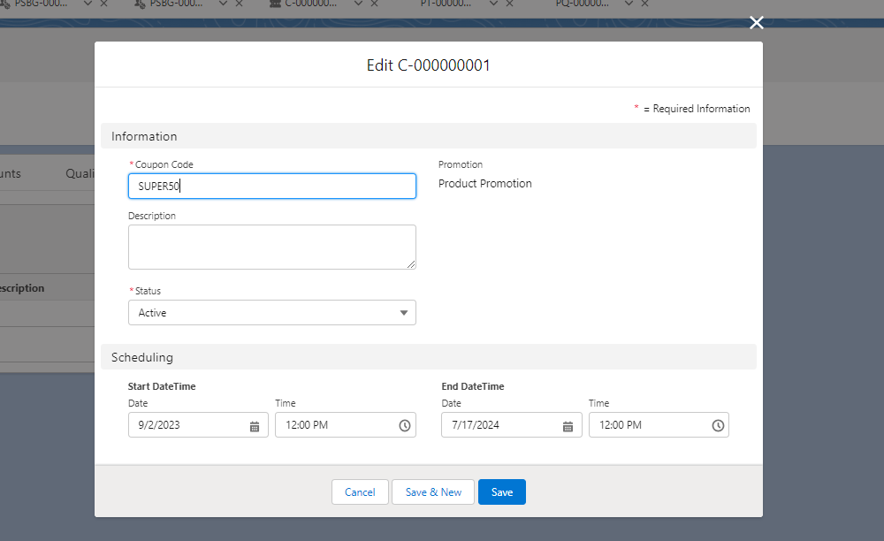

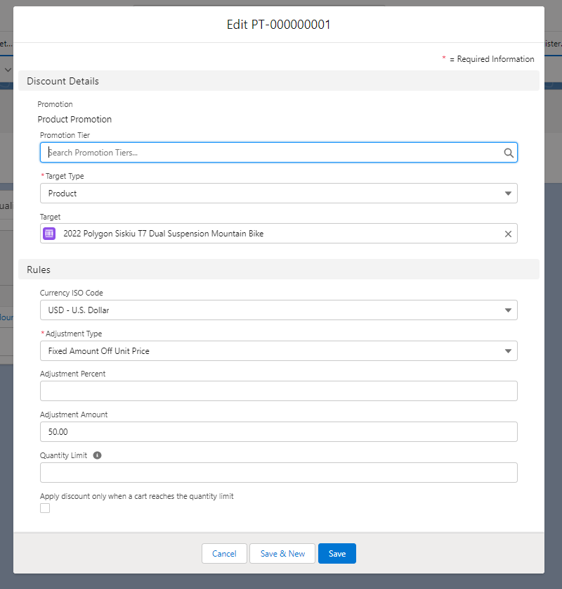

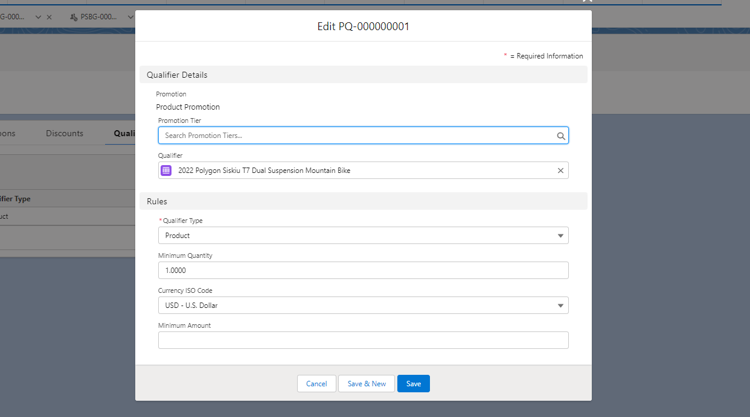

* Promotion for sub-category

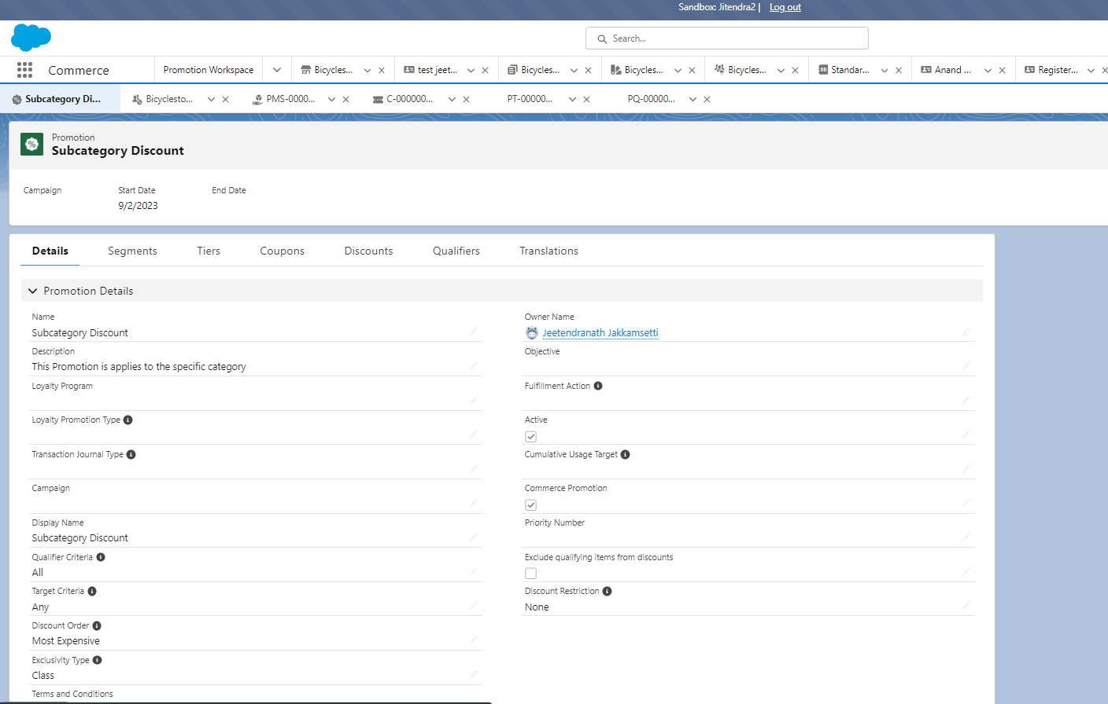

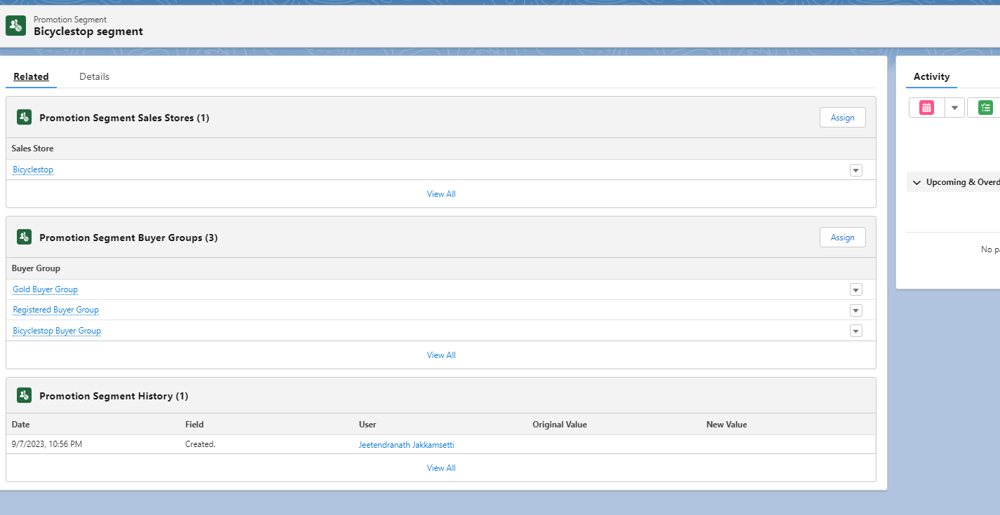

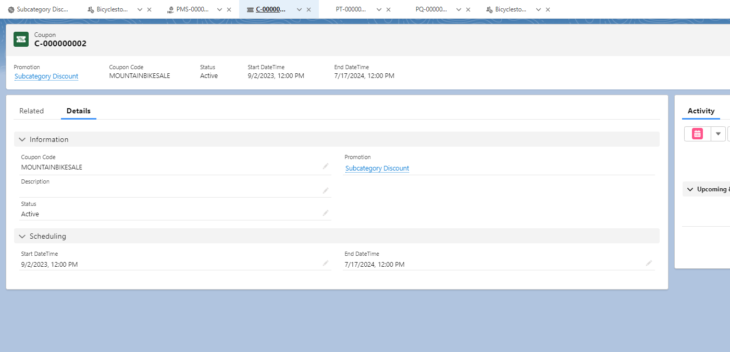

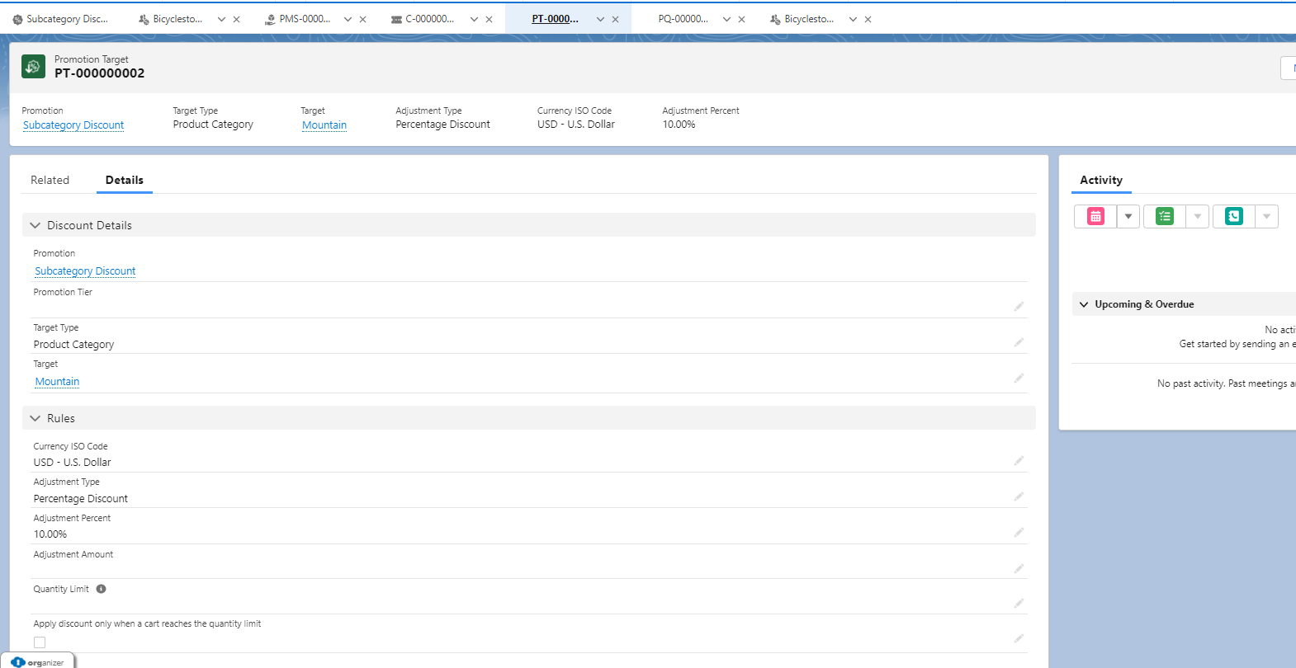

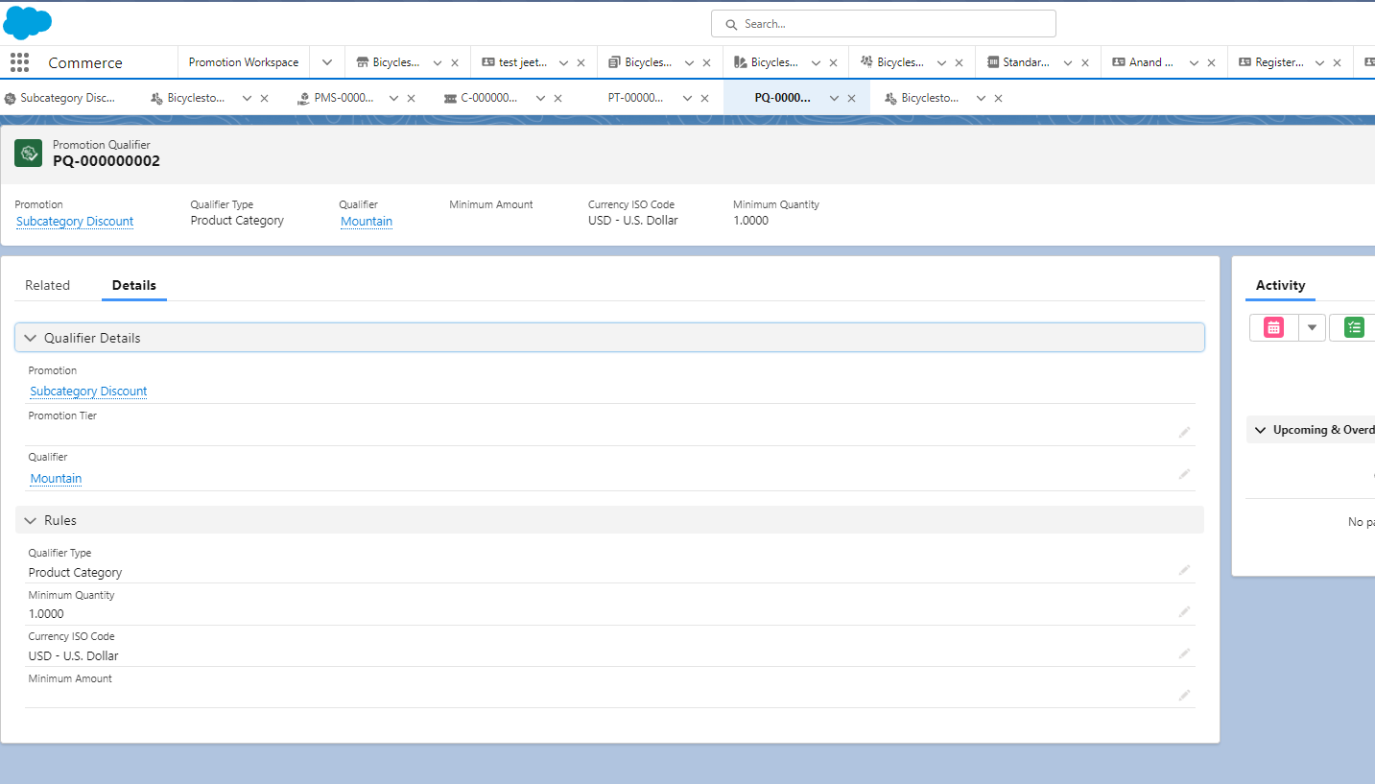

## **R-02: B2B Store**

* **Carousel**
* Created a zip file with 3 carousel images and uploaded it in the static resources.
* Created a LWC component named ‘b2B_BS_Carousel’ . we imported the static resources JS and display the images using the <lightning-carousel> tag.
* And the component was imported to experience builder and placed on home-page.
* Attaching the GITHUB link for the code below.
* **Shop by category**
* We used the standard component shop by category in the experience builder.
* **Footer with contact us**
* Created a LWC Component named ‘b2B_BS_Footer’.
* when registered user clicks on the contact us button then the lightning model will pop up and user need to enter the comments and need to click on submit to create a case for him an that case was assigned to the Online quire queue. When user tries to submit without the entering any comment then user was not able to submit the form and gets the error message.
* 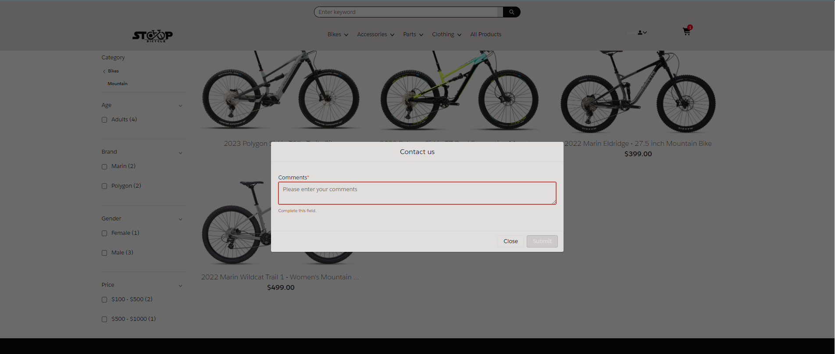
* 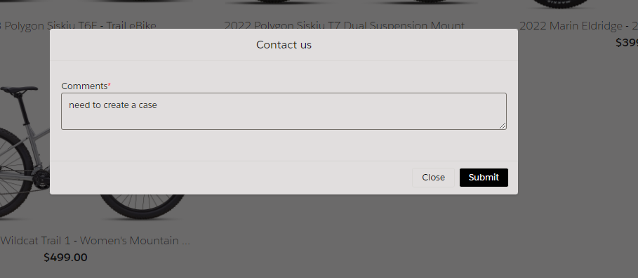
* 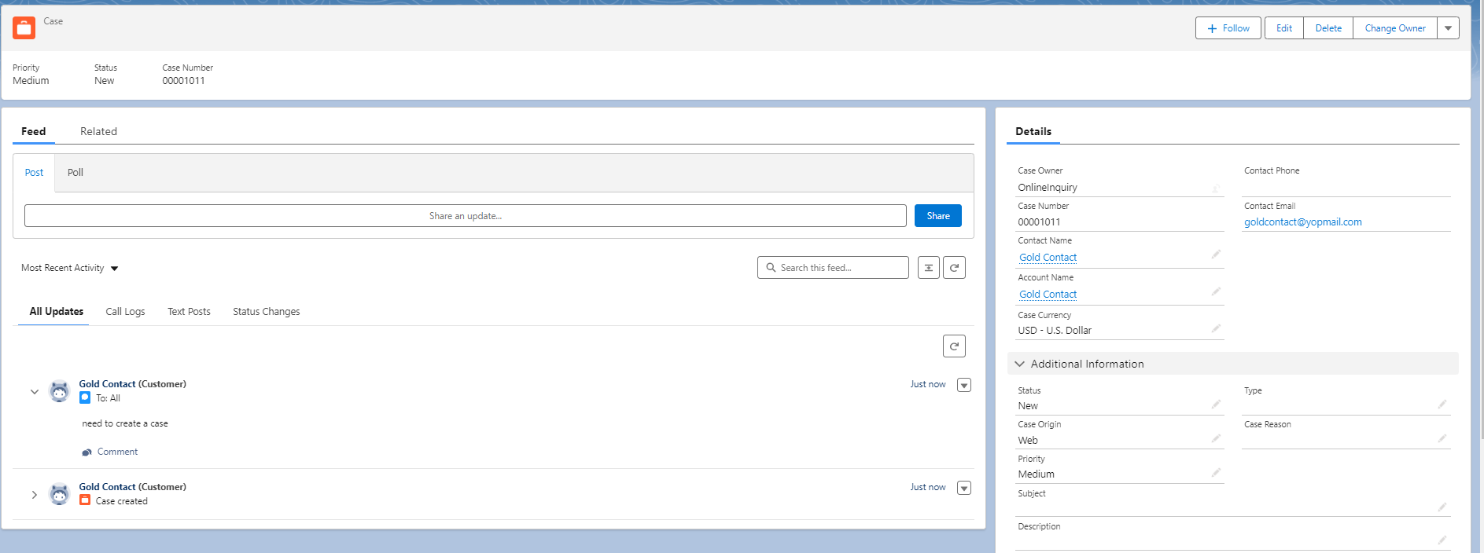
* For guest user when user clicks on the contact us button then user will see a lightning model will pop up with the First name ,last name, email, company name, comments where all fields are required any of them was null then user will get error while submit. When user submits then a Lead record will be created for that user and the record is assigned to B2B Store Queue.

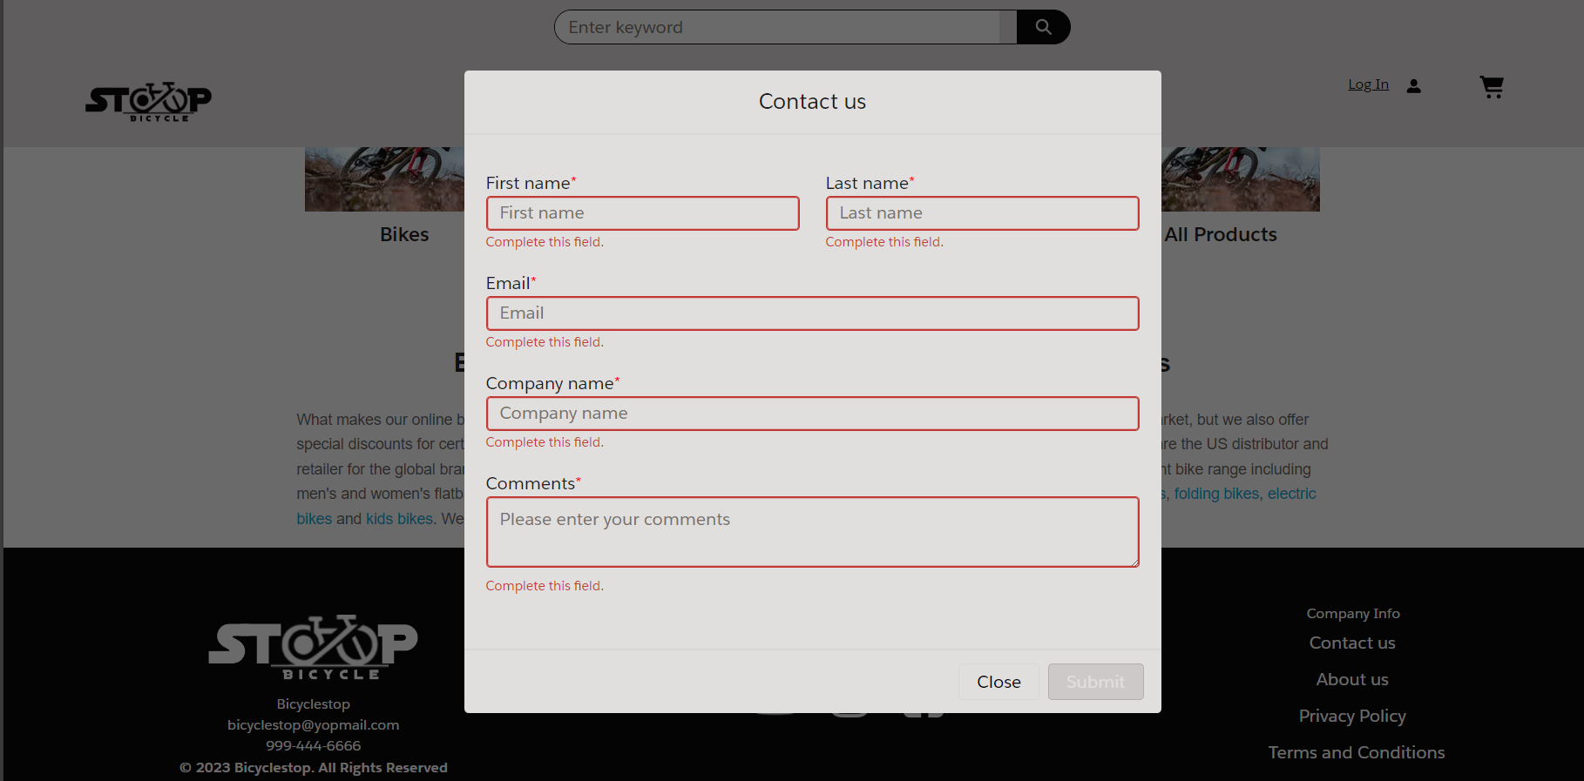

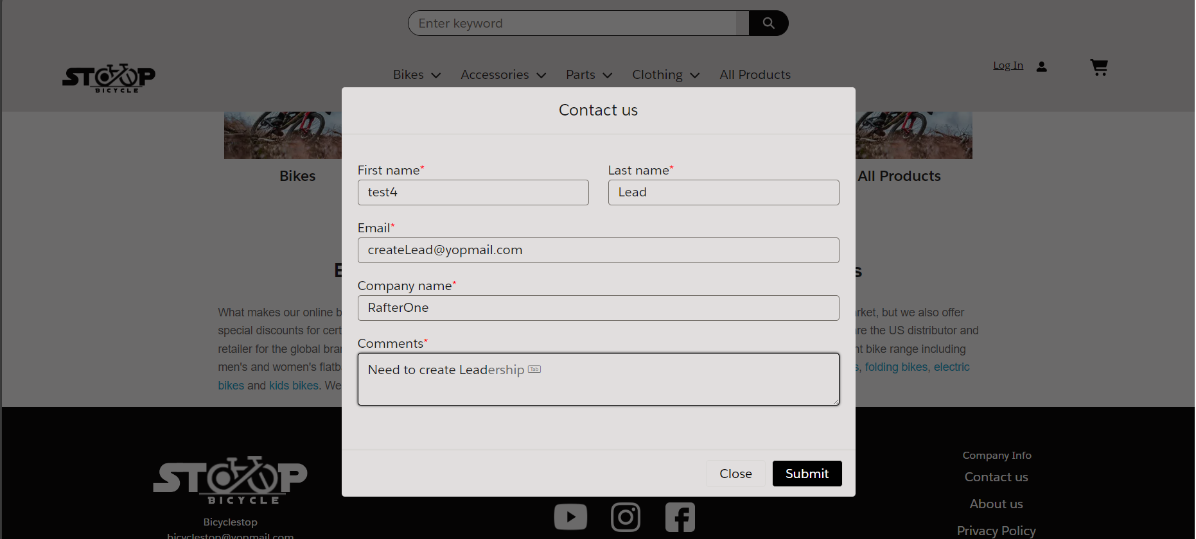

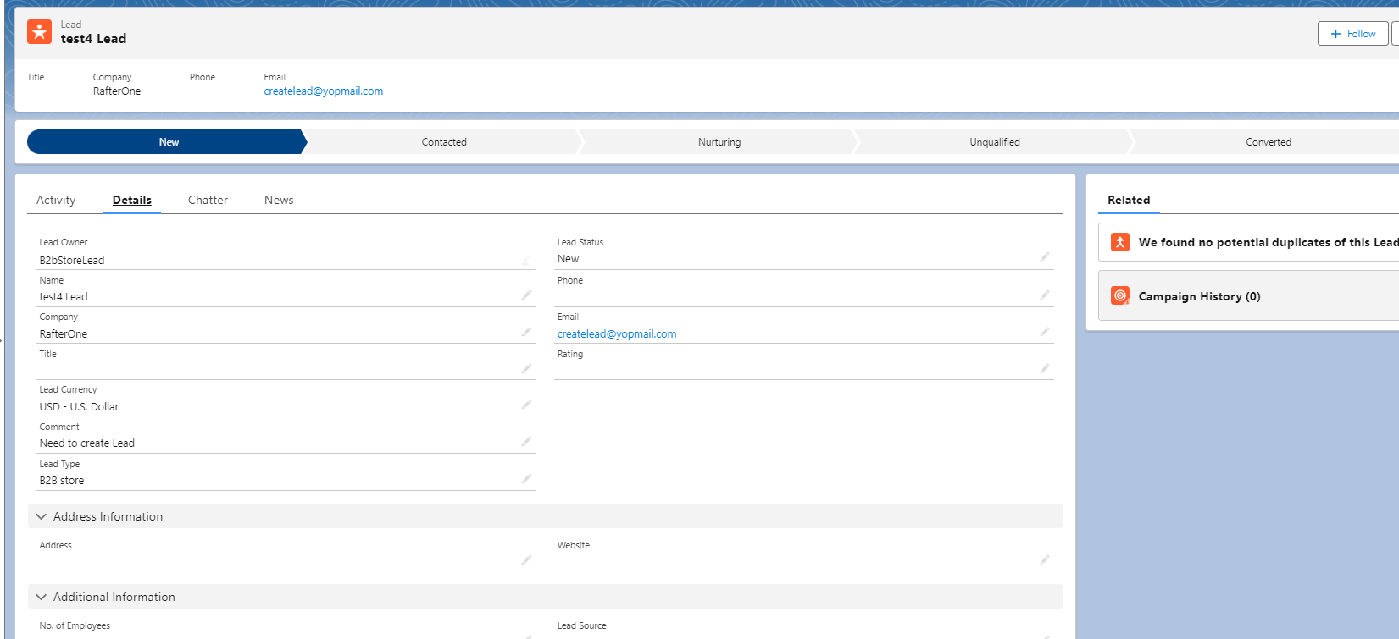

* Below attaching the link for the Footer LWC Component and the Apex class for creating lead and case
* **Product List Page (PLP)**

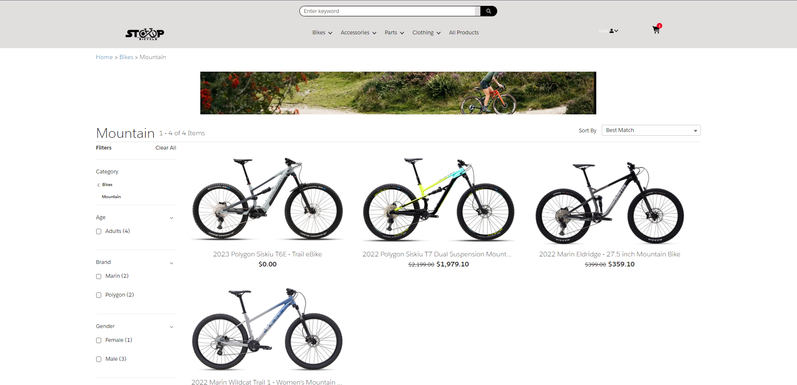

### **Product Detail Page (PDP)**

* Display the images
* Price
* Add to Cart button
* Tabs  
  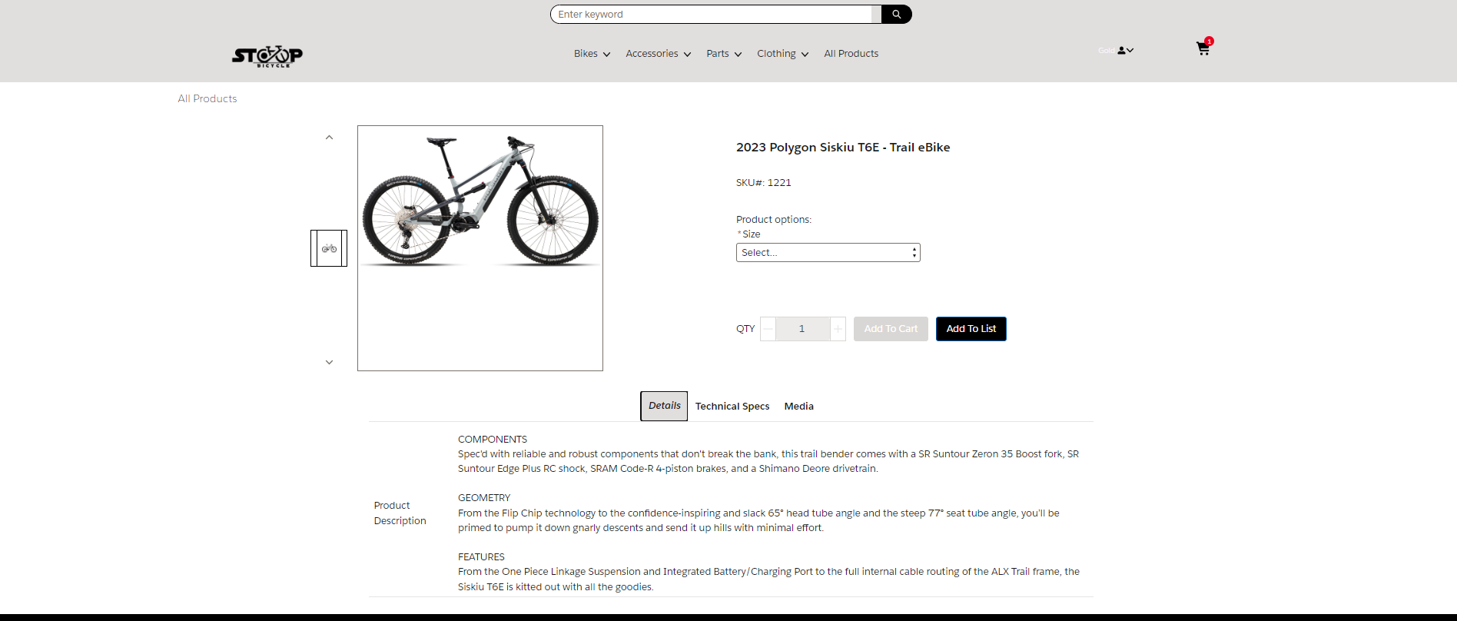
* **Product Variance**

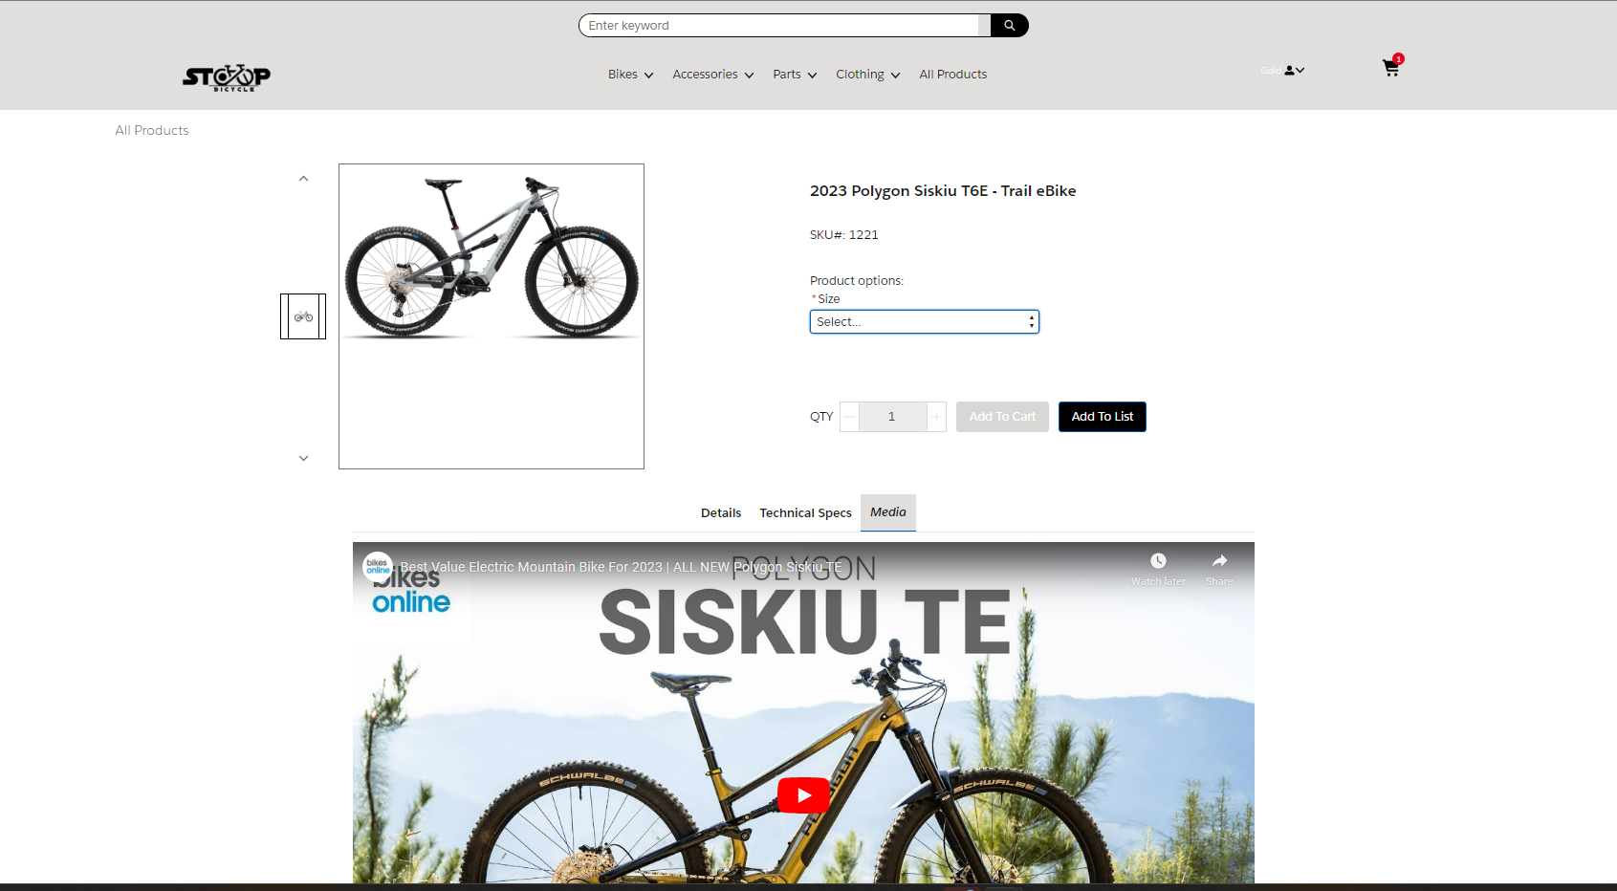

* **Registration**
* Enabled the option that guest user can register themselves to be registered user of the site in the Site administration and assigned the register Page to it.
* User needs to enter the
  + First name
  + Last name
  + Phone number
  + Email
  + Password
  + Confirm password
* User needs to enter all the fields shown on the registration form if the user tries to register even without filling then user gets an error toast message.
* 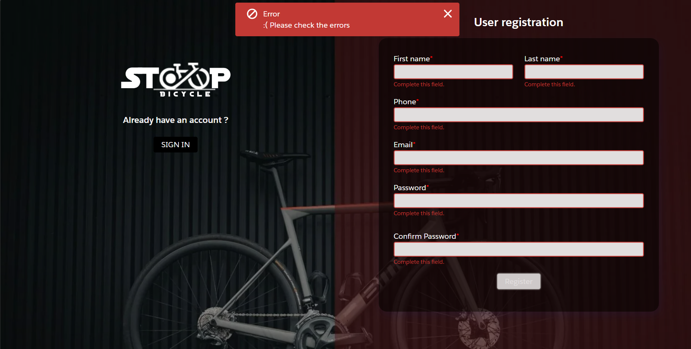
* When user password strength was week then also user was not able to register he gets an toast message.
* 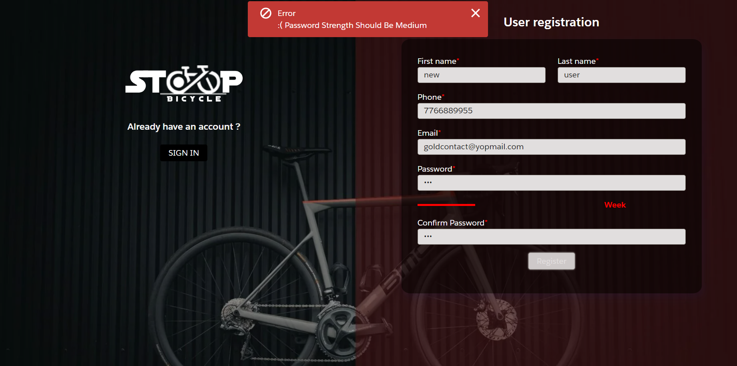
* When the password and confirm password doesn’t match then we will see a error message that password was not matched and not able to register.
* 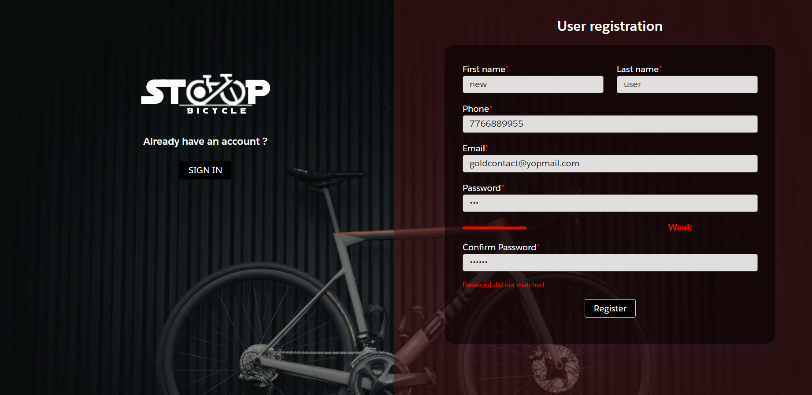
* When user enters all the data correctly and clicks on register. Then in the backend we check for the duplicate values for the entered phone and email in the contact object if found then it throws an error toast that phone or email was already registered.
* 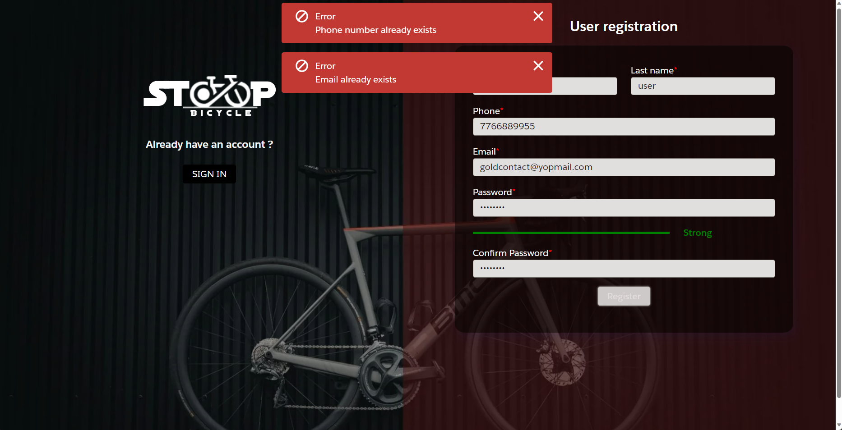
* So user needs to give a unique email and phone number to register themselves.
* In the backend when user clicks on the register then we create a account for the user and then we create contact for the user and then a create reference record for the user details and pass this user details to the site.createExternalUser method where it returns the userId then we create a page reference to login to the store through site.login method where we pass userId, password, Site URL As the parameters and return the pageURL which user needs to redirect after the successful registration.
* After the successful registration the user is assigned with the permission set group which we created in the backend.
* **Below I am attaching the link to the GITHUB for the LWC and apex code for registration.**